**Consider the following data, decision boundary, and margin boundaries**

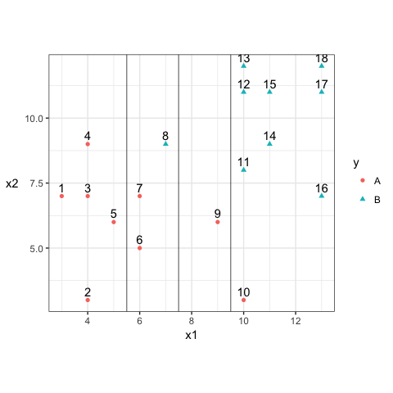

**Construct the decision rule according to this classification boundary. How would you classify a new observation that has $x_1=6$ and $x_2=10$?**

X1<7.5 – A

X1>7.5 – B

Classify new observation as A since it is less than 7.5.

**What size is the margin here?**

X1 plus/minus 2 is the margin.

**Which observations receive a penalty? Which observations are the support vectors?**

6,7,8,9,10 will receive penalty and are the support vectors

**What is the total penalty here?**

Between 0 and 1 – 6,7

Between 1 and 2 – 8,9

Greater than 2 – 10

Total Penalty = 2.25+1.75+1.25+0.25+0.25 = 5.75

**Can I choose a bigger margin if my total allowable penalty is 6?**

Yes

**Are the data separable? If so, what are the support vectors?**

No. We do not have a single hyperplane separating all the points.